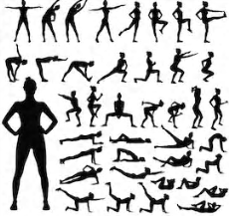
Exercise Challenge
Stay active and support your health and wellbeing by carrying out this Exercise Challenge daily/weekly, all you have to do is spell out your name with the following alphabet exercises and put them together to form a routine…
N – 15 seconds mountain climbers
O –10 sit ups
P – 15 second plank
Q – 10 seconds alternate lunges
R – 10 push ups
S – 20 second step ups on bottom stair
T – 20 seconds straight punches
U – 10 seconds speed skater
V – 15 squats
W – 10 jumping jacks
X – 30 second running on the spot
Y – 15 squats
Z – 20 second alternating lunges

A – 10 jumping jumps
B – 20 seconds mountain climbers
C – 15 squats
D – 15 push ups
E – 30 seconds running on the spot
F – 20 second alternate lunges
G – 20 second sit ups
H – 30 second step ups on bottom stair
I – 10 seconds straight punches
J – 15 second plank
K – 20 second high knee twist
L – 20 second speed skater
M – 15 jumping jacks

You can mix up your exercise routine by spelling out family/friends names too! Have fun and we would love to hear if you’ve joined in…

